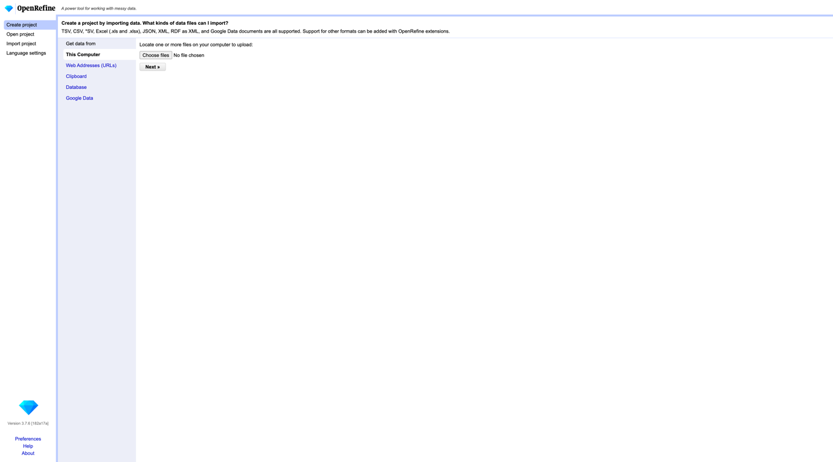

Loading bar showing data uploading

Loading bar showing project creation

Features:

* Text Facet: Allows grouping of row instances based on a given value, can sort by name and count

* Cluster feature attempts to automatically group column instances with similar names
* Trim whitespace option in columns

* Undo/redo tab, allows for extraction as JSON
* Numeric facet YT video
* Transform column
* Create new column based on old column
* Template exporting